Application Layer Security Lab
CYBR3010
Cybersecurity Foundations

Arr Domingo
Student ID: 200458099
November 30, 2025

Instructor: Sam El-Awour
Table of Contents
1 Introduction 1
2 Network Diagram 1
3 Demonstrate SSL inspection 2
3.1 Before injecting/implementing SSL inspection to VM2 3
3.2 Set up SSL inspection in the firewall for VM2 4
3.3. After injecting/implementing SSL inspection to VM2 7
4 Wireshark capture for decrypting SSL traffic 12
Before 12
After 12
5 Question and Answer 13
5.1 Explain the process of SSL/TLS interception and include how certificates are handled and the role of root certificate authorities in maintaining trust. 13
5.2 What technical challenges can occur during SSL/TLS inspection (e.g., certificate pinning, encrypted SNI, performance overhead)? Propose potential solutions or workarounds for these issues. 14
5.3 How does SSL/TLS inspection intersect with data privacy laws and compliance requirements such as GDPR, HIPAA, or PIPEDA? Provide examples of scenarios where SSL inspection might be restricted or prohibited. 15
References 1

1 Introduction
This document is about the security of application layer, specifically the configuration of SSL (Secure Socket Layer) inspection, which is a feature in the next-generation firewall that allows the firewall to intercept the SSL/TLS encrypted internet communication, such as HTTPS, between client and server. The interception would allow the FortiGate firewall to examine and manage the traffic in the network by acting as a "man in the middle", decrypting the traffic, inspecting it using security profiles, and then re-encrypting it before forwarding the traffic. Moreover, this document will show the process of injecting SSL certificate in Windows client, as well as decrypting SSL traffic in Wireshark.

2 Network Diagram
This is a detailed network setup with a focus on one windows client virtual machine (VM 2), virtual switch, and a virtual firewall. The windows client virtual machine (VM 2) is configured to have SSL/TLS certificate, and the virtual FortiGate firewall is configured to implement SSL/TLS inspection and manage/examine SSL/TLS traffic in the network.
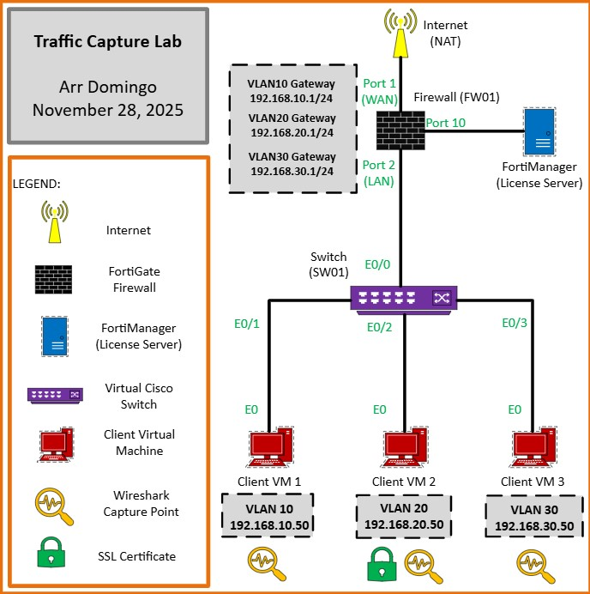
Figure 1. Network diagram of Application Layer Security.

3 Implementation of SSL inspection in the firewall
In simple terms, SSL Inspection or TLS Interception is a man-in-the-middle executed to filter out malicious content. This interceptor sits in between the client and server, inspecting all the traffic passing through it, and finally deciding whether the traffic/content is allowed or not.

3.1 Before implementing SSL inspection for Windows client VM2
- Open the browser and search something on the internet (yahoo.com, etc).
- Click on the lock icon to see what SSL certificates being signed.
- Click “Connection secure” then click “More information”. In here, it will show the security feature that is verified by DigiCert Inc, which means website is trusted.
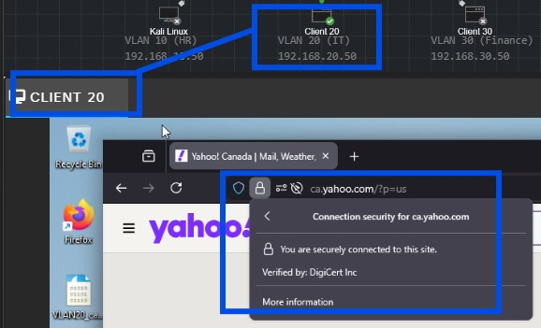
Figure 2. DigiCert Inc is digital certificates that secure websites and online transactions, manage identities for devices, and enable secure document signing.
- To check valid trusted certificate issuer in Windows, click Windows logo and search “Manage user certificates”.
- Click “Trusted Root Certification Authorities” and click "Certificates”. This will show lists of all the certificate issuer trusted by Windows which means browser would accept this certificate and make the connection secure.
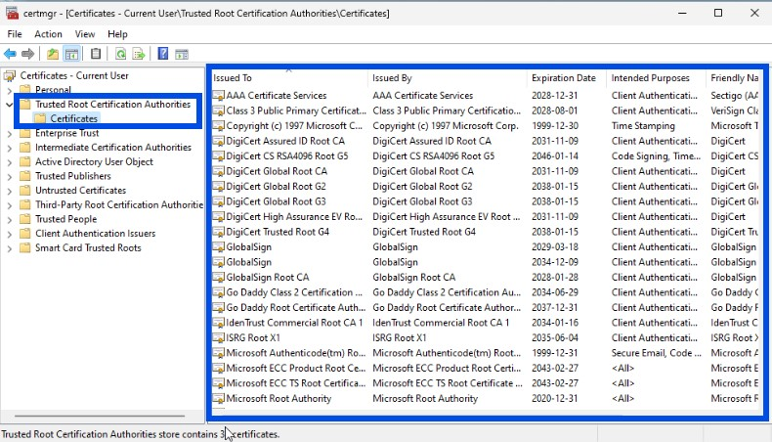
Figure 3. Certificate issuer trusted by Windows.
- At this point, the FortiGate firewall has no visibility in the traffic.

3.2 Set up SSL inspection in the firewall for VM2
- In CML, start the firewall (FW01) as well as all other devices.
- Right click the firewall (FW01) and choose “Console”. You know firewall is done booting when you are able to see the serial number and the firewall login.
- Type “cisco” in the “Firewall login” and “Password”.
- Wait until you see “Welcome”.
- Type “get system interface physical port1” to get information about port 1 that is connected to the internet. Open the IP address in another browser.
- On the browser, click “Advanced”.
- Click “Proceed to 192.168.202.146(unsafe)”.
- Type “cisco” as the Username and Password, then click “Login”.
- Click "Login Read-Write".
- Click "Yes".
- Click "Begin".
- In the Dashboard Setup, choose the default which is "Optimal" and press "OK".
- Firewall (FW01) dashboard will open up.
- In the FortiGate firewall (FW01) dashboard, click “Policy & Objects”.
- Click “Firewall Policy”.
- Base from the previous configuration, click “Edit” to the policy related to VM 2 which is “IT(VLAN20)”.
- Enable “AntiVirus” and on “SSL inspection”, choose “deep-inspection”.
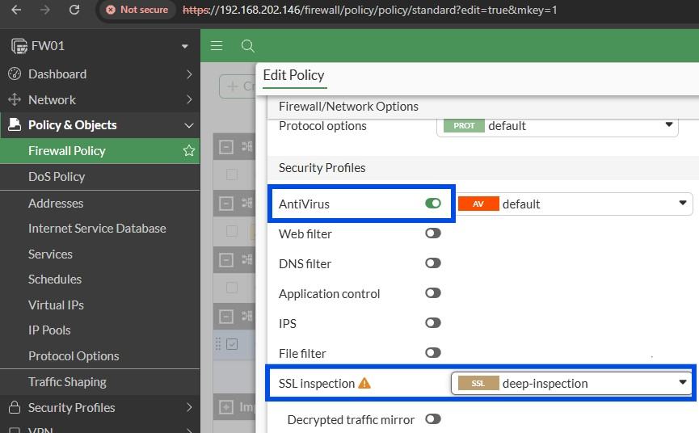
Figure 4. Enable antivirus and set SSL inspection to deep-inspection.
- Click OK.
- Confirmation will appear which means end users will see certificate warnings. Hit OK.
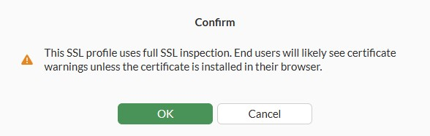
Figure 5. Confirmation message after SSL configuration.

3.3. After implementing SSL inspection for Windows client VM2
- Go back to the CML and close the previous browser. Open new browser.
- Go to yahoo.com. Warning will appear.
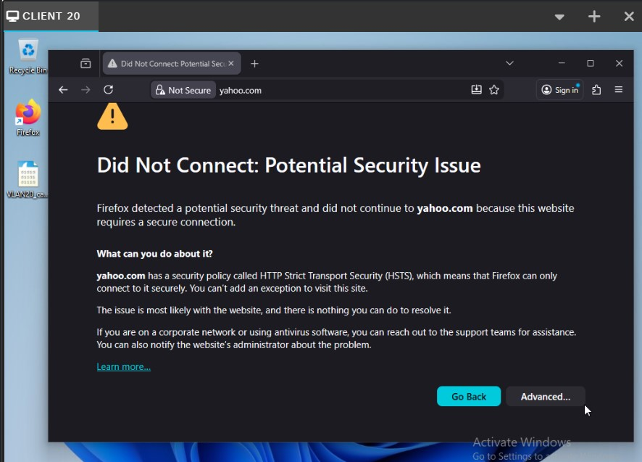
Figure 6. Warning message after the implementation of SSL inspection in FortiGate firewall. This means that browser does not trust the security certificate presented by FortiGate. To fix this, the FortiGate’s CA (Certificate Authority) certificate must be injected in VM 2 windows client and add to their trusted root certificate authorities store.

4 Injection of SSL Certificate to the client (VM2)
SSL certificate is a digital certificate that authenticates a website's identity and enables an encrypted connection. The purpose of using SSL certificate is to establish a secure and encrypted connection between a web server and a browser. It uses encryption algorithms to scramble data in transit, which prevents hackers from reading it as it is sent over the connection.

4.1 Before the injection of SSL certificate to Windows client (VM2)
- Every time you search a website in a browser, there will always be a warning message.
Figure 7. Warning message before the injection of SSL certificate.
- To eliminate this warning message, take the SSL certificate from the firewall and inject it into the trusted certificate in VM 2 Windows client virtual machine.

4.2 Process to inject SSL certificate to Windows client (VM2)
- First is to download the certificate from the firewall. To download the certificate, go to CMD and run “ipconfig” command to check “Default Gateway”.
- Paste the default gateway which is 192.168.20.1 in browser tab. Notice that it doesn’t go through.
- To resolve this, go to FortiGate firewall, click “Network” and click “Interfaces”.
- Click the + sign beside “LAN (port2)” and double-click the VLAN20.
- Under “Administrative Access”, check the “HTTPS”.
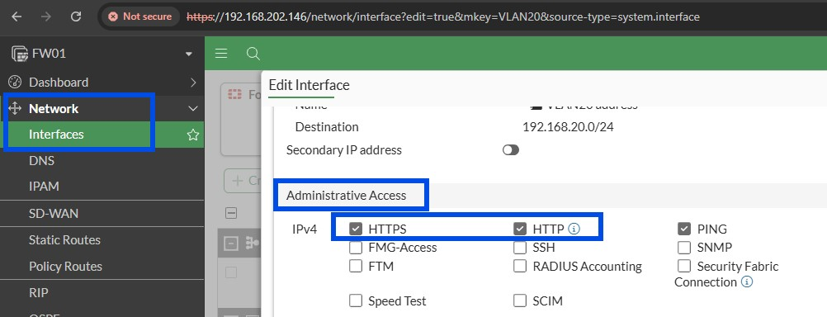
Figure 8. Allow HTTPS and HTTP in VLAN20.
- Click OK.
- By now, you can open FortiGate firewall with the self-signed certificate in the browser of VLAN20.
- Go to “Security Profiles”, click “SSL/SSH Inspection”, then double-click “SSL deep-inspection”.
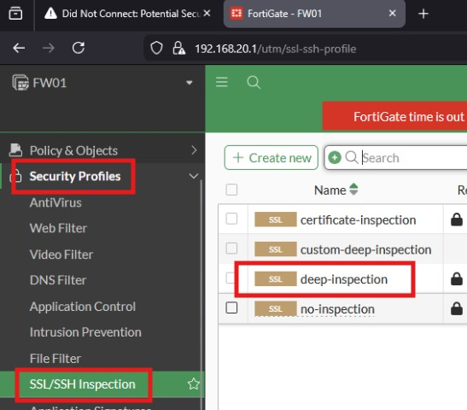
Figure 9. Process to check SSL deep-inspection details.
- Where you see “CA certificate”, this will tell you the firewall certificate which is “Fortinet_CA_SSL”. Click “Download”. (Note that in real world, firewall certificate will normally be downloaded within a certificate server like windows domain controller.)
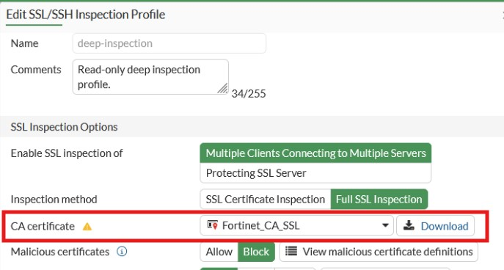
Figure 10. Downloading SSL certificate in FortiGate firewall.
- Open the downloaded SSL certificate.
- Click “Install Certificate”.
- Choose “Local Machine” then click “Next”.
- Choose “Place all certificates in the following store”, then click browse and choose “Trusted Root Certification Authorities”. Finally, click OK.
- Click Next.
- Click Finish. Successful message will pop-up.
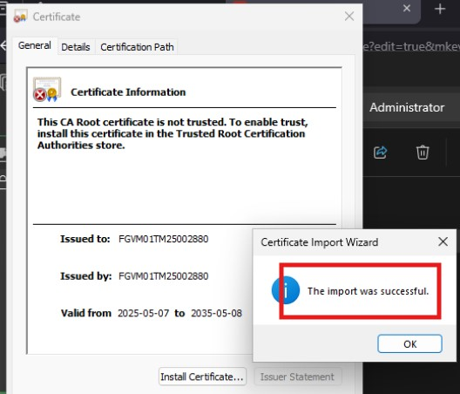
Figure 11. Successful installation of SSL certificate.
- Click OK.

4.3 After the injection of SSL certificate to Windows client (VM2)
- To verify, open the browser once again and search yahoo.com. By this time, you can now access the website with no certificate warning. This means that connection is now trusted.
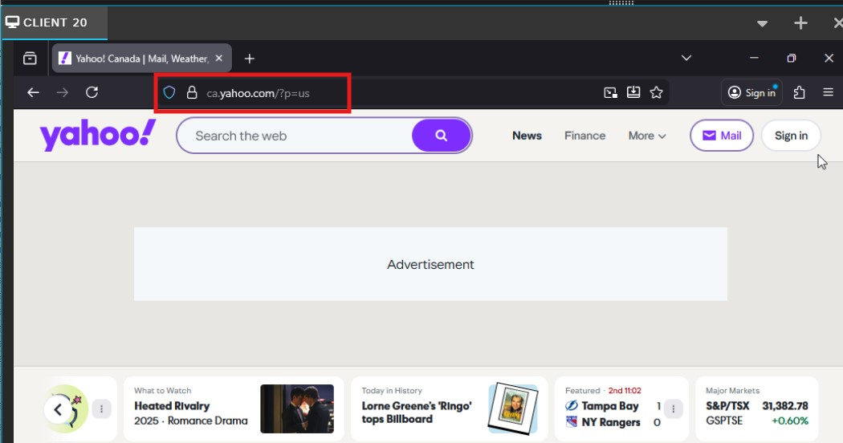
Figure 12. No more warning message.

5 Wireshark capture for decrypting SSL traffic
SSL/TLS decryption is the process of intercepting and decrypting encrypted internet traffic to inspect its contents for security threats like malware or phishing attacks. It involves using methods like a private key to unscramble the data, making it visible to security tools so they can identify and block malicious activity that might be hidden within encrypted sessions.
To decrypt SSL traffic in Wireshark, you need a key log file, which contains the session keys, generated by a client application during a capture. The process involves setting an environment variable to generate the log file, capturing the traffic, and then configuring Wireshark to use that log file and provide the path to the log file.
- On VM 2 (VLAN20), open Wireshark as well as the browser (Mozilla Firefox).
- On Wireshark, start the packet capture. On Mozilla Firefox, open multiple websites.

5.1 Before SSL decryption in VM2
- Generate the key log file by typing “environment” in Windows search bar.
- Click the “Edit the system environment variables”.
- “System Properties” window will appear. Click “Environment Variables” button.
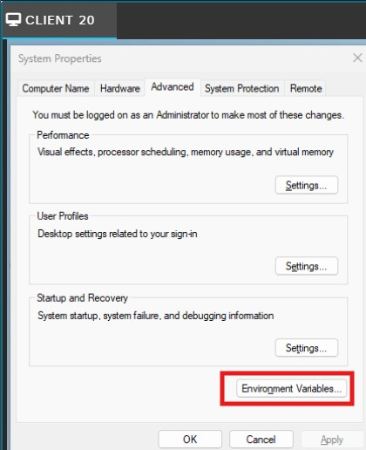
Navigating environment variables.
- Click “New” under “User variables for Administrator”.
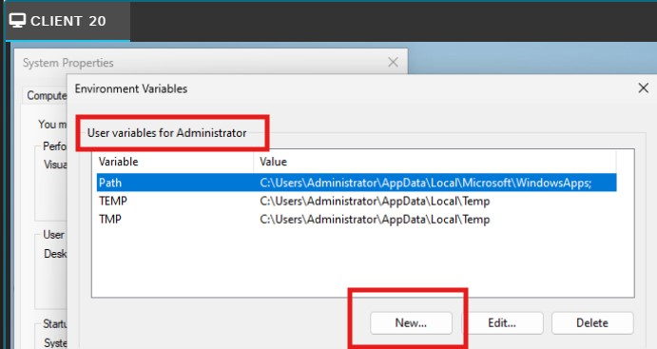
Navigating environment variables.
- Type “SSLKEYLOGFILE” in the Variable name.
- Type this file path “C:\Users\Administrator\Documents” in the Variable value. Note that variable will automatically log the session keys for all subsequent traffic from that application.
- Click OK twice.
- SSLKEYLOGFILE variable is now created.
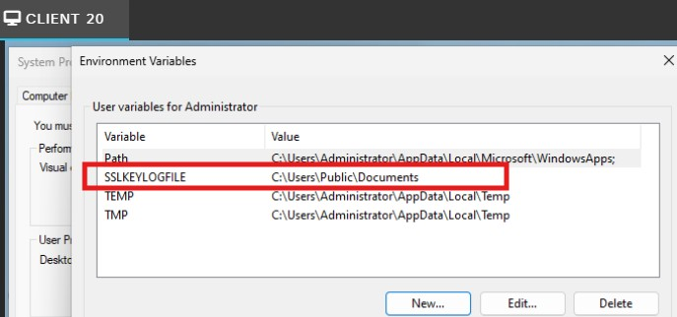
SSLKEYLOGFILE variable.
- Open Wireshark and start a new capture on the appropriate interface.
- Open the browser and search multiple websites or services you want to capture. The keys will be logged in the specified file.
- Stop the capture in Wireshark when you are finished.

5.2 After SSL decryption in VM2
- In Wireshark, go to “Edit” then click “Preferences”.
- Expand “Protocols” and select “TLS”.
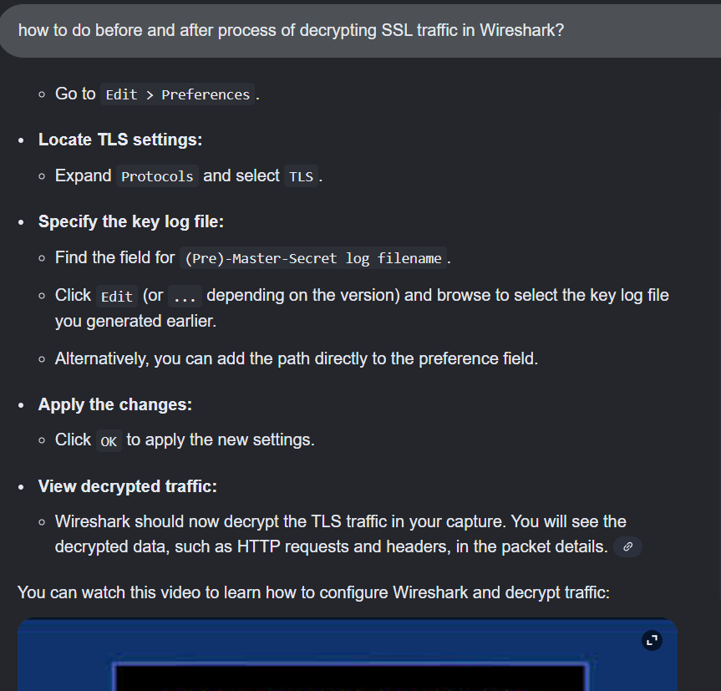

6 Question and Answer

6.1 Explain the process of SSL/TLS interception and include how certificates are handled and the role of root certificate authorities in maintaining trust.
SSL (Secure Sockets Layer) refers to a protocol for encryption to keep user data secure, authenticate communications that take place on the websites, and stop attackers from tampering with internet communications. TLS (Transport Layer Security) is the successor technology to SSL which was replaced in 2015 after it was compromised by several vulnerabilities. Most people use the common term SSL because it's more widely known.
SSL/TLS interception works by allowing a firewall to temporarily act as a man-in-the-middle (MITM) in encrypted web traffic so it can apply security checks.
- The client tries to connect to a secure website.
- The firewall stops the request and creates two separate TLS sessions:
- One between the client - firewall
- One between the firewall - real server
- To keep the browser from warning the user, the firewall re-signs the website’s certificate using its own internal CA (Certificate Authorities) certificate.
- If the client trusts that CA, the browser accepts the connection as valid.
- The firewall decrypts the traffic, scans it for threats, then re-encrypts it and sends it on.
Root Certificate Authorities is a trusted CA (Certificate Authorities) required so the browser does not display security warnings. When the firewall’s CA certificate is added to the client machine, it becomes trusted where browser treats the firewall like any legitimate CA.

6.2 What technical challenges can occur during SSL/TLS inspection (e.g., certificate pinning, encrypted SNI, performance overhead)? Propose potential solutions or workarounds for these issues.
These are some challenges that occur during SSl/TLS inspection:
- Certificate Pinning
Some apps embed the server’s certificate or public key. If the certificate changes (because of inspection), the app rejects the connection. The solution is to bypass the inspection for pinned services (e.g. banking apps, updates).
- Encrypted SNI (Server Name Indication)
When SNI is encrypted, the firewall can’t identify the domain being requested, making filtering harder. The solution would be to use domain-category based rules, or DNS filtering.
- Performance Overhead
Decrypting and re-encrypting traffic is CPU-intensive. The solutions is to use hardware capable of SSL acceleration, limit inspection to high-risk categories, and avoid decrypting streaming/video sites.

6.3 How does SSL/TLS inspection intersect with data privacy laws and compliance requirements such as GDPR, HIPAA, or PIPEDA? Provide examples of scenarios where SSL inspection might be restricted or prohibited.
SSL inspection can expose sensitive user data. Some laws regulate or restrict this:
GDPR (Europe)
- Requires a lawful reason to inspect traffic.
- Personal data must be minimized.
- Employees usually must be notified.
HIPAA (U.S. healthcare)
- Protects medical information.
- SSL inspection may violate rules if PHI is decrypted without strict controls.
PIPEDA (Canada)
- Requires consent for collecting personal information.
- SSL inspection may not be allowed for personal accounts.

Examples where SSL inspection is prohibited
- Banking websites
- Government portals
- Healthcare portals
- Some encrypted messaging apps (due to pinning or privacy laws)

References
A Lock, Two Keys and Strong Identity. (n.d.). Retrieved from digicert: https://www.digicert.com/tls-ssl/tls-ssl-certificates
CyberSec. (n.d.). FortiGate SSL Deep Inspection – Basic Behavior Explained. Retrieved from Youtube: https://www.youtube.com/watch?v=t2HDzenmNWc&t=32s
Hacksi. (n.d.). How to DECRYPT HTTPS Traffic with Wireshark. Retrieved from Youtube: https://www.youtube.com/watch?v=eeikugGyiIg
How does SSL work? | SSL certificates and TLS. (n.d.). Retrieved from Cloudflare: https://www.cloudflare.com/learning/ssl/how-does-ssl-work/
Thakkar, J. (2018, August 3). What is SSL Inspection? How does it work? Retrieved from HashedOut: https://www.thesslstore.com/blog/ssl-inspection/
What is an SSL certificate – Definition and Explanation. (n.d.). Retrieved from kaspersky: https://www.kaspersky.com/resource-center/definitions/what-is-a-ssl-certificate
What Is SSL Inspection? (n.d.). Retrieved from Zscaler: https://www.zscaler.com/resources/security-terms-glossary/what-is-ssl-inspection

